fields | keys | data types | validation of data | Data foramt | rang
Guest ID | PK | int | Uuique,not null | Numder | 0,99999999
Guest Name | - | Varchar(50) | not null | Name | 6
Phone Numbe | - | int | not null | Number | 0,09999999
Check In Date | - | date | not null | Date | 4
Check In out | - | date | not null | Date | 4

fields | keys | data types | validation of data | Data foramt | rang
Room Number | PK | int | Uuique,not null | Numder | 0,99999999
Room Type | - | Varchar(50) | not null | Name | 6
Capacity | - | int | not null | Number | 0,09999999
PricePerNigh | - | Int | not null | number | 0,999999
Status | - | int | not null | Taxe | 0.99999

fields | keys | data types | validation of data | Data foramt | rang
Room Number | Fk | int | Uuique,not null | Numder | 0,99999999
Guest ID | FK | int | Uuique,not null | Numder | 0,99999999
Booking ID | PK | int | Uuique,not null | Numder | 0,99999999
Booking date | - | date | not null | Date | 4
Check In Date | - | date | not null | Date | 4
Check out Date | - | date | not null | Date | 4

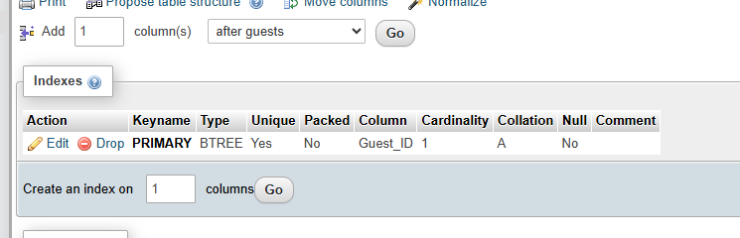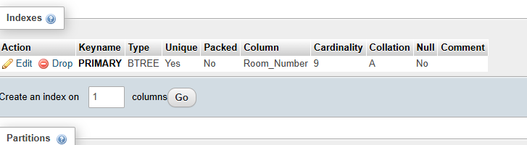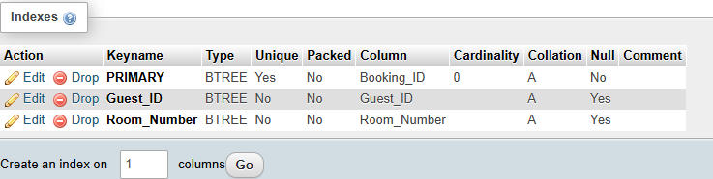
CREATE TABLE Guest (
Guest_ID INT PRIMARY KEY,
Guest_Name VARCHAR(50) NOT NULL,
Phone_Number VARCHAR(15) NOT NULL,
Check_In_Time Time NOT NULL,
Check_Out_Time Time NOT NULL,
Guests INT NOT NULL
);

CREATE TABLE room (
RoomNo INT PRIMARY KEY,
RoomType VARCHAR(50) NOT NULL,
Capacity INT NOT NULL,
PricePerNight INT NOT NULL,
Status VARCHAR(50) NOT NULL
);
Skip 1

CREATE TABLE Booking (
BookingID INT PRIMARY KEY,
Guest_ID INT NOT NULL,
RoomNo INT NOT NULL,
BookingDate DATE NOT NULL,
Check_In_Time TIME NOT NULL,
Check_Out_Time TIME NOT NULL,

FOREIGN KEY (Guest_ID) REFERENCES Guest(Guest_ID),
FOREIGN KEY (RoomNo) REFERENCES Room(Room_Number)
);

CREATE TABLE users (
id INT AUTO_INCREMENT PRIMARY KEY,
username VARCHAR(50),
password VARCHAR(50)
);

INSERT INTO users(username, password)
VALUES ('admin', '1234');

